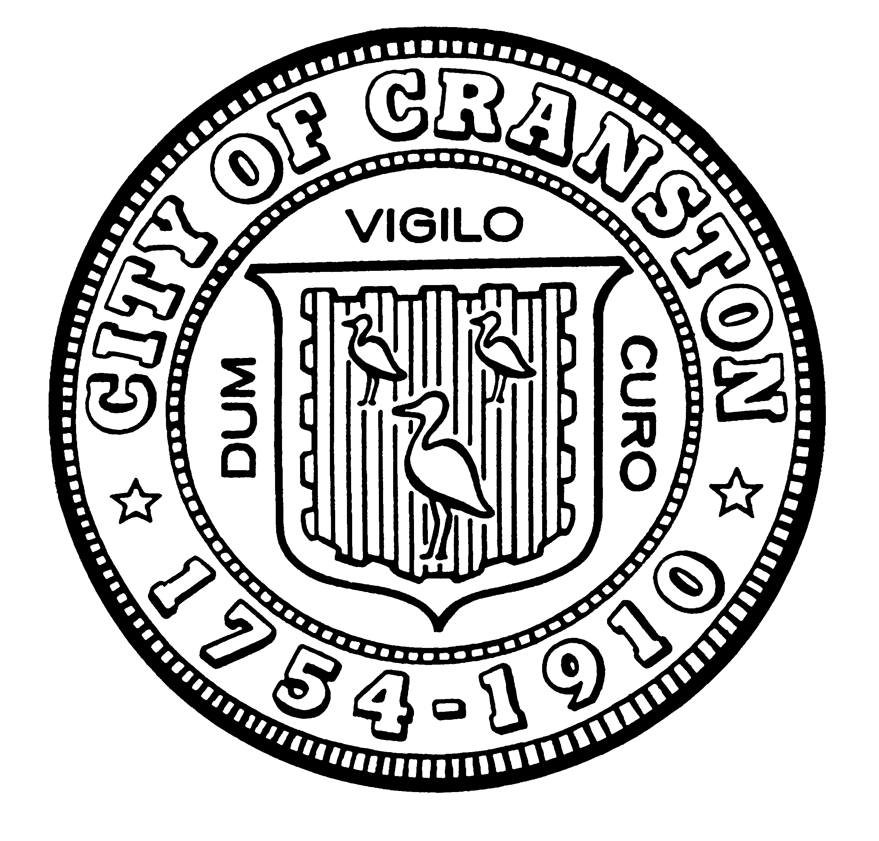

HOUSING COMMISSION

Annette Mann Bourne, Chair
Robert Santurri Jr, OneCranston Health Equity Zone, Vice Chair
Amy Rainone, Secretary
Ernest Tommasiello, Director, Department of Community Development
Jason Case
Frank DiZoglio III
Joanne McGunagle, CCAP
Jason M. Pezzullo, Planning Director
Derik Tutt

WEDNESDAY DECEMBER 7, 2022 @ 5:30 P.M.
Cranston City Hall, 869 Park Avenue
3rd Floor Conference Room

MONTHLY MEETING- NOVEMBER AGENDA

- Approval of minutes of November 2, 2022 meeting (for vote)
- Update regarding letter to City Council on Accessory Dwelling Unit law (for discussion and possible vote)
- Review of terms (those to end 2023) and intention to seek reappointment; Preparation for new officers in 2023 (January 4th meeting) (for discussion)
- Discuss goals for the Housing Commission in the coming year (for discussion)
  - Presentation to City Council
  - Review of use of ARPA funds—any remaining for housing production?
  - Review of intended housing actions in City’s existing plans (CDBG, Comprehensive Plan) and work of OneCranston Health Equity Zone’s Built Environment working group
  - Plan for meeting with Planning Commission and Zoning Board
  - Develop list of priority best practices for residential development
  - Explore actions of improving health and safety of Cranston’s existing rental stock
  - Review of state laws that passed in 2022 that affect housing
- New business (for discussion)

“Individuals requesting interpreter services for the hearing-impaired must notify the Office of the City Clerk at 461-1000 Ext. 3197 seventy-two (72) hours in advance of the hearing date.”

